**UNIT 7**

Getting a job/ A job interview.

Qualities and skills needed for a job in ICT.

CV and letter of application

Think of your ideal job and write a letter of application for it (project).

1. **Read these job adverts. Which industry sectors do the companies operate in?**
2. Do you like working in an exiting modern industry? We are looking for web designers to join our **talented** team. We need **creative thinkers**, but you also need to be **practical**. Of course, you’ll also be **hard working**- the hours are long, but the rewards are high! Have you got what it takes?
3. With a chain of stores throughout the country, we can offer an exciting career for **ambitious** people. We are looking for trainee managers, so we need people with good **leadership** skills who are also **team players**.
4. Do you want to be part of our busy call centre team? We are recruiting now for sales staff with good **communication skills** and the ability to be **independent** and **self-motivated**. Excellent telephone skills are essential in this job. Call us for more information.
5. **Match these definitions with skills mentioned in the adverts:**

* Able to work alone
* Good at talking to people and explaining thinks
* Have a natural ability to do something well
* Putting a lot of effort into a job
* Willing and able to work hard without being told what to do
* Determined to be successful, rich, powerful, etc.
* Able to think of new ideas or produce something new
* Able to lead a team successfully
* Sensible and realistic.

1. **Look at some of the common questions asked at interviews:**

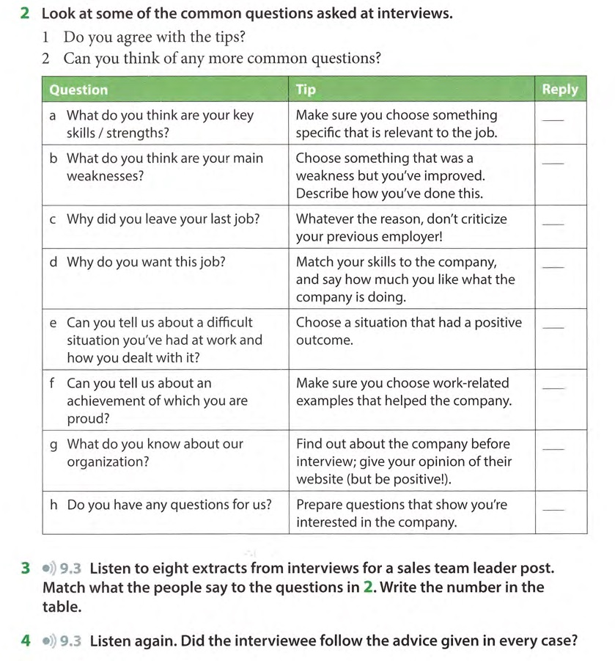

1. **Sort these adjectives into six pairs with opposite meanings:**

*reliable sensible hard-working lazy enthusiastic reckless experienced laid-back unreliable uptight inexperienced unenthusiastic*

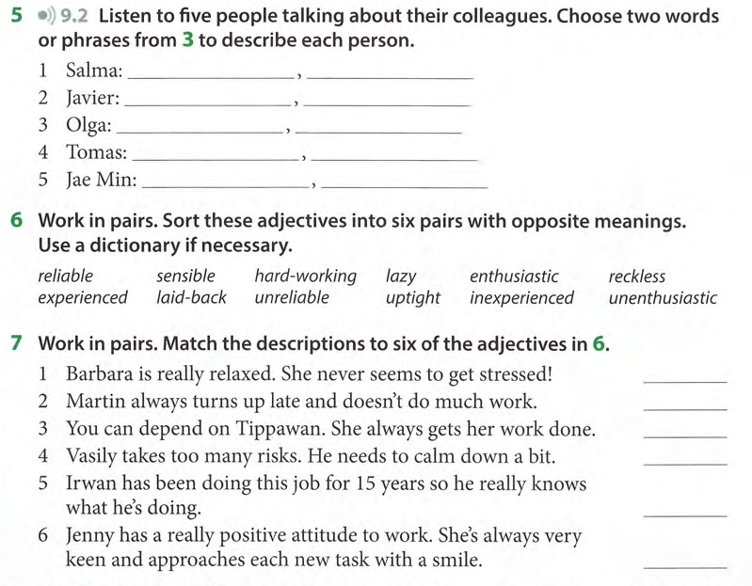

1. **Job interview**

Watch these videos to learn useful language and techniques for finding and selecting candidates, applying for a job and performing well in an interview.

**<https://learnenglish.britishcouncil.org/business-english/youre-hired>**

1. **Letter of application**

**Salutations**

If you know the name of the person you are writing to use the title (Mr, Mrs, Miss or Ms) and the surname only. If you are writing to a woman and do not know if she uses Mrs or Miss, you can use Ms, which is for married and single women.

**Examples:** “*Dear Mr Simpson,” / “Dear Mrs Flanders,” / “Dear Miss Skinner,” / “Dear Ms Van Houten,”*

You must then finish with **Yours sincerely,**

If you do not know the name of the recipient of the letter begin with “*Dear Sir,”/ “Dear Madam,” or “Dear Sir or Madam,”*

You must then finish with **Yours faithfully,**

**Opening Lines**

The first paragraph states the reason(s) for writing and, if needed, what you are responding to (an advert). In addition, an opening paragraph is needed to make reference to previous correspondence:

*I would like to apply for … which I saw advertised in ….*

*I am writing with regard to …*

*I am writing with reference to…*

*I am writing in response to…*

*Thank you for your letter of 9 May… /for your letter regarding…*

**Main content:**

Here you need to sell yourself:

What are you studying now?

What qualifications do you have?

What relevant work experience do you have?

What personality traits do you have?

What are your strengths/weaknesses?

*I have been studying … for …*

*I am an expert in …*

*I am skilled in …*

*People tell me I am … and …*

*I have experience in …*

Good adjectives: hardworking, competent at, outstanding in, excellent, responsible, resourceful, articulate.

**Closing**

Say when you’re available for interview or for the course.

Make a request if necessary.

*I am available for … from … / at …*

*I would be grateful if you could …I would be interested in having more details about…*

*I would like information on…*

*I look forward to hearing from you soon / I look forward to receiving your reply*

*Should you need further information, please do not hesitate to contact me.*

**Final Salutation**

Depending on how you started your letter you will end your letter with

**Yours sincerely,** OR **Yours faithfully,**

Sign your name and then print your name clearly underneath on another new line.

Mr. J Humphris